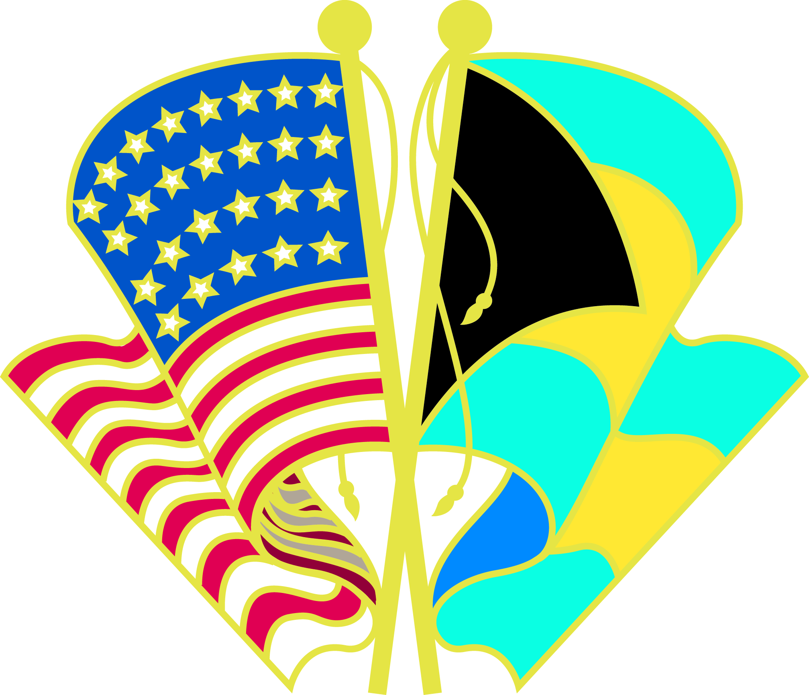

GOLD COAST TRADE MISSION TO THE BAHAMAS
SEPTEMBER 29 – OCTOBER 1, 2008
SHERATON HOTEL, CABLE BEACH
NASSAU, BAHAMAS

PROPOSED SCHEDULE

Monday, September 29

11:00 a.m. – 5:00 p.m. Trade delegation arrive in Nassau

6:30 p.m. – 8:30 p.m. Welcome reception hosted by Ambassador Ned Siegel
Ambassador’s Residence – Liberty Overlook,
Sanford Drive

Tuesday, September 30

8:00 a.m. – 10:00 a.m. Roundtable breakfast on “Doing Business in The Bahamas”
Presentations by:
- Bahamas Investment Board
- Bahamas Chamber of Commerce
- Bahamas Hotel Association
- Bahamas Financial Services Board
- Bahamas Real Estate Association
- Bahamas Contractors Association

10:30 a.m. – 4:00 p.m. One-on-one matchmaker appointments.

6:30 p.m. – 8:30 p.m. Reception

Wednesday, October 1

VISIT TO GRAND BAHAMA ISLAND

PROPOSED SCHEDULE

8:00 a.m. Depart Nassau for Freeport, Grand Bahama

9:00 a.m. – 10:30 a.m. Breakfast briefing on investment opportunities in Grand Bahama by the Grand Bahama Development Company

11:00 a.m. – 12:00 p.m. Meeting with Chris Gray, CEO, Container Port and Tour of the Grand Bahama Container Port

12:30 p.m. – 1:45 p.m. Lunch and presentation by the Grand Bahama Chamber of Commerce

2:00 – 3:45 p.m. One-on-one matchmaker meetings
Press conference

5:00 p.m. Depart Freeport for Nassau

7:00 p.m. – 9:00 p.m. Closing Mix & Mingle Business reception and Press conference in Nassau hosted by Chamber of Commerce

